

STUDENT CASE STUDY EXECUTION REPORT

Department | FED
Subject | DSA-2
Academic Year | I-III Semester (2025-26)
Faculty Name | Balaiah G
Student Name | I.Vikram
Roll Number | 2520090118
Branch | CSIT
Course Outcome | Apply BST and AVL trees to insert, delete, search hierarchical datasets

Case Study Topic: WhatsApp delivered-receipts ordering-quick AVL design check Work Done Summary:
In this case study, delivery receipt timestamps are inserted into a tree. A normal BST becomes skewed because timestamps arrive in increasing order, making searches very slow. To solve this, an AVL Tree is used. After each insertion, the tree checks its balance factor and performs rotations (LL, RR, LR, RL) if needed. This keeps the tree balanced, maintains a height of O(log n), and ensures fast searching and retrieval of receipts

Implementation Details:
- Insert node as in BST.
- Update height of each node.
- Calculate Balance Factor.
- If imbalance occurs:
- LL → Right Rotation RR → Left Rotation
- LR → Left + Right Rotation
- RL → Right + Left Rotation
- Tree becomes balanced again.

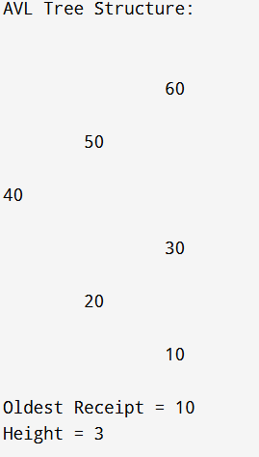
Result: Screenshots / Output:
The case study shows that a normal BST is not suitable for storing continuously increasing timestamps because it becomes skewed and very slow. By using an AVL Tree, the tree remains balanced through rotations, keeping its height small. This reduces search time from O(n) to O(log n), allowing receipt retrieval to be performed very quickly and ensuring the system meets its performance requirements
GitHub Link: https://github.com/vikramimmella/DSA2-case-studies.git

